17.122: From the result of Problem 17.121, the heat current through each of the jackets is related to the temperature difference by 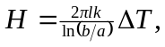 where l is the length of the cylinder and b and a are the inner and outer radii of the cylinder. Let the temperature across the cork be 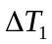 and the temperature across the styrofoam be 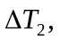 with similar notation for the thermal conductivities and heat currents. Then, 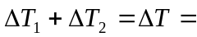 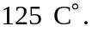 Setting 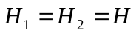 and canceling the common factors,
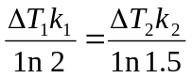
Eliminating 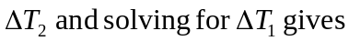 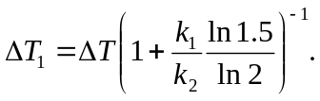
Substitution of numerical values gives 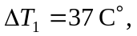 and the temperature at the radius where the layers meet is 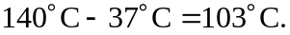 b) Substitution of this value for 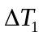 into the above expression for 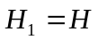 gives
